Accessing Microsoft E-mail, OneDrive, Office 365, and Teams

Accessing your GCS Student Email from a GCS connected computer:
- Log-in to the computer using your student ID and birthdate.
- Click the Windows Start button in the lower left corner (see image below) and scroll to the tool that you want to access.

Accessing your GCS Student Email and tools from a non-GCS computer:
- Go to webmail.gcsnc.com
- Login:
Username: student ID (lunch number)
If entering just the student ID does not work, try entering your full email address: 123456@stu.gcsnc.com (replace 123456 with your student ID)
Password: Birthdate in format of mmddyyyy (i.e. Aug 8, 2005 becomes 08082001)

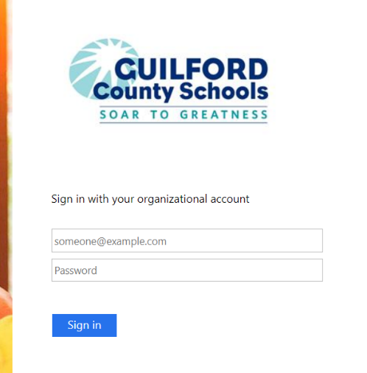

- You are now in your email.

Accessing your GCS OneDrive, Teams, Office Apps such as Word, Excel, and PowerPoint:
- In the upper left corner, click the App Launcher button.

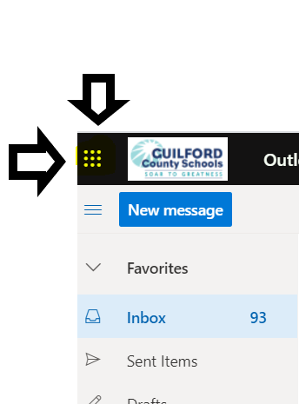

- You will then see a list of apps available to you:
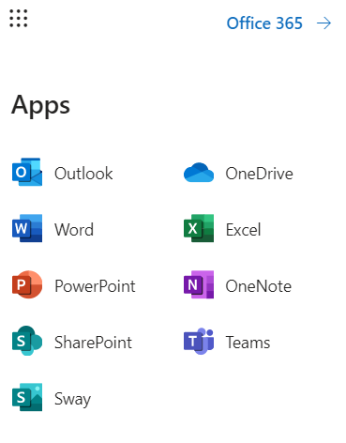
- Click on the app you need.
- To get to another app, click the app launcher again. If you want to open the app in a new window, right click it and choose “Open in a New Window”.

